Mill Lane
Primary School



Asthma Policy

Date written: Nov 2022
Adopted from: NHS
Date adopted by Governors and Staff: Nov 2026
Review Date: Nov 2028



Asthma friendly schools logo

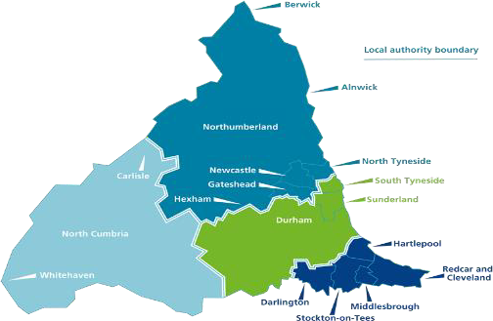


Mill Lane Primary School

Asthma Policy

School name Mill Lane Primary School Head Teacher/Principal Sue Skillcorn Asthma Champion/ Lead Rachel Petch School nursing team contact number Claire Caygill 077411185916 Date November 2026 Policy review date November 2028

As a school, we recognise that asthma is a serious, but controllable condition. The school welcomes all children/ young people with asthma and aims to support these children in participating fully in everyday school life. School will take on a whole school approach to Asthma to support the children/ young people. We aim to actively involve parent/ carers/ children/ young people in the management of asthma within school.

This policy has been developed within the North East and North Cumbria CHWN following National guidelines for the management of children/ young people (CYP) with asthma.

Indemnity statement

School staff should be willing to assist with inhaler administration when it has been recommended by an appropriate healthcare professional.

The importance of Asthma

- Asthma is the most common chronic condition, affecting one in eleven children.
- On average, there are two children with asthma in every classroom in the UK
- There are over 25,000 emergency hospital admissions for asthma amongst children a year in the UK.
- Children with persistent, uncontrolled, or severe asthma are more likely to miss school, compared to children with mild asthma.
- Every September, more children are rushed to hospital due to their asthma than at any other time of the year.
- Research studies suggest that asthma is responsible for up to 18% of school absences, with evidence improved asthma control improves school attendance and performance.

What is Asthma?

Asthma is a condition that affects small tubes (airways) that carry air in and out of the lungs. When a child with asthma is exposed to something that irritates their airways (an asthma trigger), the muscles around the walls of the airways tighten so that the airways become narrow and inflamed. Sticky mucus or phlegm also builds up, which can further narrow the airways. These reactions make it difficult to breathe, leading to symptoms of asthma.

The most common day-to-day symptoms of asthma are:

  - Dry cough
  - Wheeze (a ‘whistle’ heard on breathing out) often when exercising
  - Shortness of breath when exposed to a trigger or exercising
  - Tight chest
  - Tummy ache in younger children

Medication and inhalers

There are many forms of treatment for asthma. All children with asthma will have some form of inhaled treatment.

Preventer and reliever inhalers:

The ‘preventer inhalers’ take time to build up in the system. They help stop asthma symptoms developing at all by protecting the airways. They can also reduce the risk of a potential life-threatening asthma attack. They are taken every day and usually at home.

The ‘reliever inhalers’ help symptoms to go away once they have started. These are the inhalers used during an asthma attack. It is important that in school the reliever inhaler is administered in the correct way if needed.

There is also a type of inhaler with both preventer and reliever combined. This is known as MART (maintenance and reliever therapy). This inhaler can be used according to the PAAP (Personalised Asthma Action Plan).

CYP are encouraged to carry their reliever inhaler, we would expect this to be by Key Stage 2 as soon as they are responsible enough to do so. However, we will discuss this with each child’s parents or carer.

Some CYP may have several other medications which are taken morning and/or night, as prescribed by the doctor/nurse. These medications need to be taken at home regularly and correctly for maximum benefit.

Parents should be encouraged to report to school if their CYP has any changes in the treatment plan (PAAP)

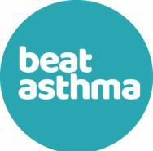
HOW TO RECOGNISE AN ASTHMA ATTACK

It is important to recognize the signs and symptoms of an asthma attack in a Child/Young person (CYP). The onset of an asthma attack can gradually appear over days. Early recognition can reduce the risk of a hospital admission.

A CYP may have one or more of these symptoms during an asthma attack:

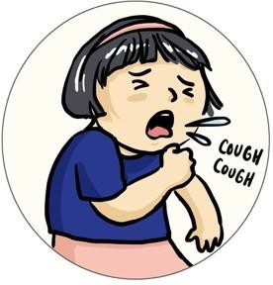
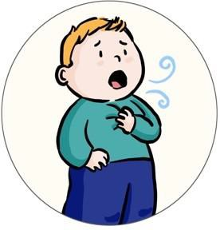
BREATHING HARD AND FAST
You may notice faster breathing or pulling in of muscles in between the ribs or underneath the ribs. (recession)

WHEEZING
This is typically a high-pitched whistling noise heard on breathing in and out, a sound produced by inflamed and narrowed airways that occur in asthma.

COUGHING
A cough may become worse , particularly at night preventing your child from having restful sleep and making them seem more tired in class.

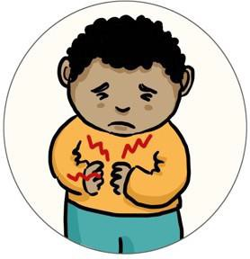
BREATHLESSNESS
A child may become less active and reluctant to join in activities. Lack of interest in food or restlessness can be a sign that the child is too breathless to exercise or eat.

TUMMY OR CHEST ACHE
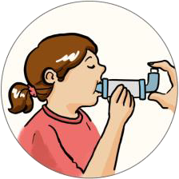
Be aware that younger children often complain of tummy ache when it is actually their chest that is causing them discomfort.

INCREASED USE OF THE RELIEVER INHALER
If the CYP is old enough, he/she may ask for the reliever inhaler more frequently during an attack. It is important that you follow the asthma action plan and recognize that if the reliever inhaler is not helping that it is time to seek medical help.
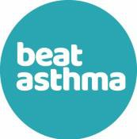

How Do I Manage a Child/Young Person Having an Asthma Attack?
What are you seeing?

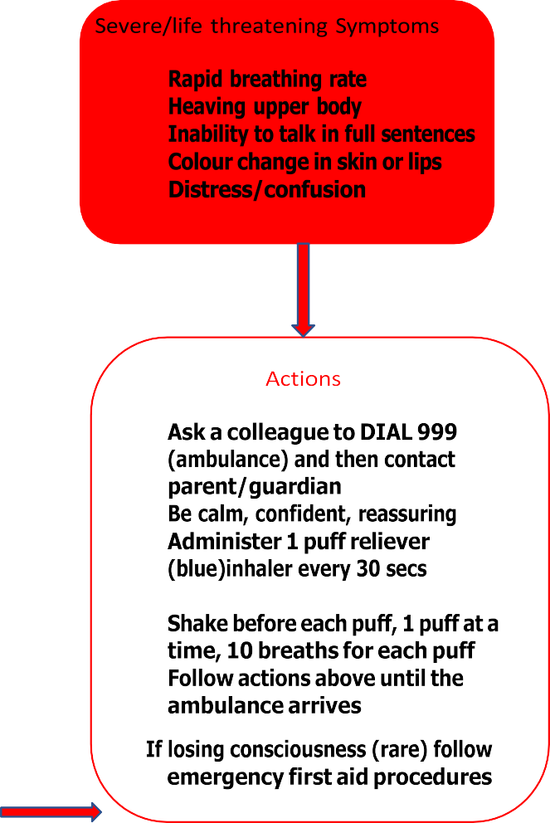
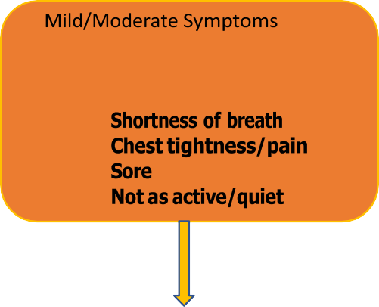
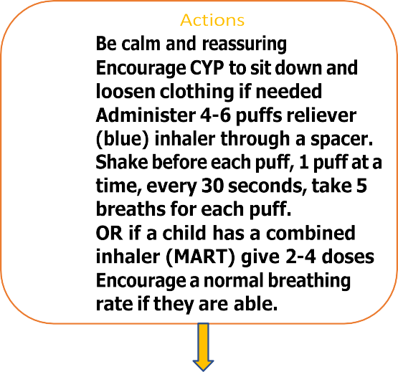

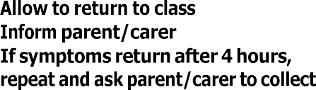

•
•
•
•
•
•
Cough Wheeze
tummy
•
•
•
•
•
•
•
•
•
•
•
•
through a spacer
•
•
•
Is the CYP responding?
No
•
by a member of staff
•
•
•

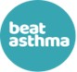
Supporting CYP with Asthma: Legal requirements Checklist
All the resources mentioned in the checklist are available through the Beat Asthma Schools home page

School Asthma policy | - Supporting Pupils in school with Medical condition (Department for Education 2015) available for all staff to read and to use as guidance when developing policies  - Guidance on the use of Emergency Salbutamol Inhalers in Schools (Department of Health, Sept 2014) available.  - School asthma policy in place, developed using guidance from above and updated regularly – all staff to be made aware of the policy and where to access it  - Information available on inhaler devices and how to use them.  - System in place to identify pupils who have frequent absences from school due to asthma
Asthma Register | - Have a named individual responsible for asthma  - Ensure school asthma register in place and updated regularly. Must state name and date of birth of child/young person.  - Register available to all staff – suggest displaying in school office/staff room with a photo board  - Ensure every CYP have an individual healthcare plan (IHCP) completed. School asthma care detailed on the IHCP and supported where needed with a specific asthma management plan
Medications | - Asthma medication is provided by the parent for school use with instructions of when and how to use, in keeping with their IHCP.  - A system is in place to check the expiry dates of any medication and a system to replace when expired or almost empty  - School staff and CYP know where their inhaler and spacer are kept – must be accessible at all times  - Inhalers should be kept in a cool environment  - If using a metered dose inhaler (“puffer” type), a spacer device must also be provided by the parent.  - Medication must be clearly labelled with a pharmacy label displaying name/dose/instructions  - Usage of reliever medication must be recorded, and parents informed.

Pupils that self-manage | - If a CYP carries their own inhaler as part of their IHCP, a spacer and metered dose inhaler should be available for them to use in school – provided by the parent  - Parents should be informed if a CYP who self manages appears to be using their inhaler more than usual  - Encourage every CYP to carry a copy of their school plan in their personal planner
Staff Training | - Recommended that all school staff (not just first aiders) attend an asthma awareness session https://www.educationforhealth.org/course/supportin g-children-and-young-peoples-health-improving- asthma-care-together/  - Asthma attack flow chart displayed in school – all staff to be familiar  - Staff administrating inhalers should be knowledgeable of the correct technique
Emergency Inhaler kits  - To use if pupils own not available | - Suggest minimum x 3 emergency inhaler kits are purchased to keep in school as part of school asthma policy, conveniently located in key areas  - Can only be used for CYP who have a diagnosis of asthma or have been prescribed a salbutamol inhaler with the exception where parents have submitted the opt out consent.  - An emergency kit should be taken out of school for offsite activities/residential trips  - Each kit should consist of:  - Asthma register (with parental consent)  - 1 large volume spacer device  - 1 salbutamol 100mcgs per puff inhaler  - Information leaflet on how to administer  - Asthma attack flow chart  - Inhaler actuation chart  - Letter template to send to the parent informing them that the emergency inhaler/spacer has been used.  - Every inhaler and spacer following use should be returned to pharmacy for disposal and recycling

Emergency Salbutamol Inhaler in School

As a school we are aware of the guidance, ‘The use of emergency salbutamol inhalers in schools from the Department of Health’ (March 2015), which gives guidance on the use of emergency salbutamol inhalers in schools. The document can be found on https://www.gov.uk/government/uploads/system/uploads/attachment_data/file/41646 8/emergency_inhalers_in_schools.pdf.

This guidance enables our school to have spare relief inhalers and spacers. Our kits are kept in the main office.

School Trips/Residential Visits

No child will be denied the opportunity to take part in school trips/residential visits because of asthma, unless so advised by their GP or consultant. The child’s reliever inhaler will be readily available to them throughout the trip, being carried either by the child themselves or by the supervising adult in the case of Key Stage 1 children.

For residential visits, staff will be trained in the use of all the CYP regular treatments, as well as emergency management. It is the responsibility of the parent/carer to provide written information about all asthma medication required by their child for the duration of the trip. Parents must be responsible for ensuring an adequate supply of medication is provided which is clearly labelled with the prescribed instruction. Group leaders will have appropriate contact numbers and a copy of each Personal asthma action plan (PAAP) see below.

A school spare reliever inhaler will be taken on the trip as advised in https://www.gov.uk/government/uploads/system/uploads/attachment_data/file/41646 8/emergency_inhalers_in_schools.pdf

Personal Asthma Action Plans (PAAP) Appendix 4/5 example

National Guidance recommend that every CYP who has asthma is provided with a Personal asthma action plan PAAP. This would ensure asthma symptoms are managed effectively.

A personalised asthma action plan.
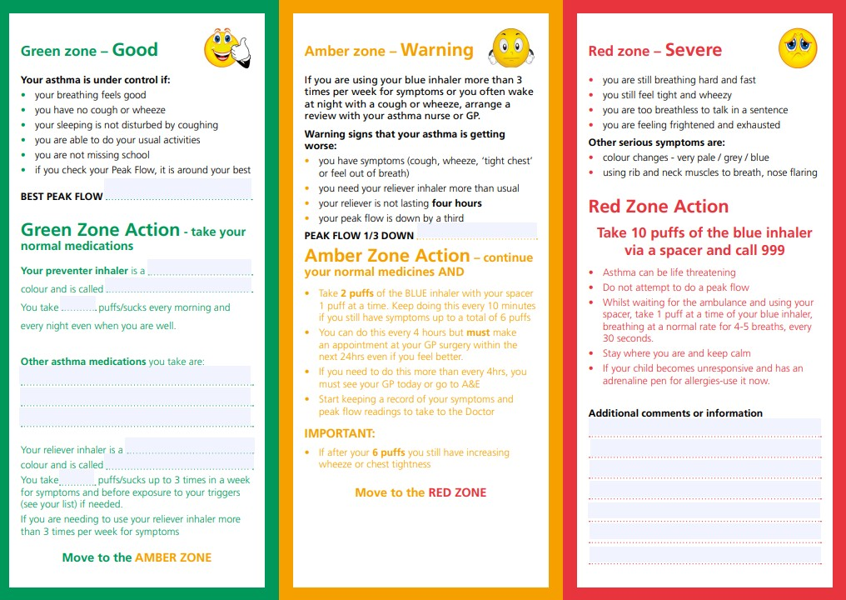

A school personalised asthma plan
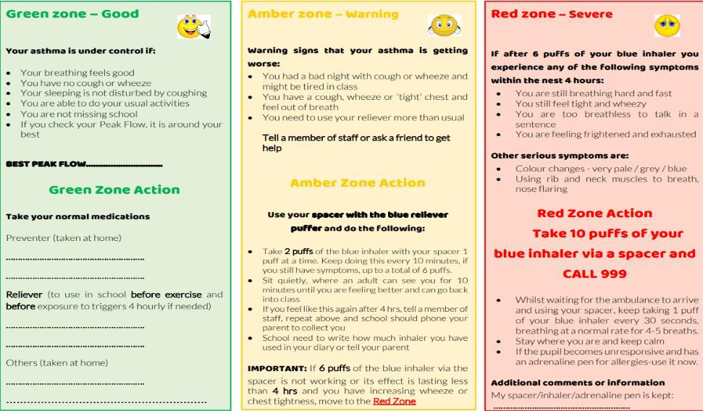

School Environment

The school does all that it can to ensure the school environment is favourable supports CYP with asthma. The school has a definitive no-smoking policy. Triggers will be recorded in the asthma action plans (PAAP). It is not always possible to avoid all triggers. Awareness/assessment of common triggers to asthma can reduce risk. Potential triggers in school
Chemicals/fumes as far as possible, pupils should try to avoid fumes in science, art and craft lessons that are known to trigger their asthma. They may need to leave the room until the fumes are no longer in the room
Mould/damp Classrooms should be well aired and ventilated. Any evidence of damp/mould within school should be acted on quickly. Where possible, autumn leaves falling from trees, forming piles should be kept away from pupil areas and regularly removed as the mould from these can be a trigger to asthma.
Grass and Pollens Pupils with asthma should be able to use their salbutamol regularly every 4 hours if the pollen count is known to be high or if they are having troublesome hay fever symptoms. Pupils may need to be given an option to do indoor PE if the pollen count is high. Where possible, grass cutting should be avoided during school hours or limited to late afternoons.
Aerosols/sprays Many children have asthma that can be triggered by strong odours and aerosols. Ensure changing rooms are well ventilated and encourage the use of roll-on deodorants and unscented products. Consideration should be given to allowing pupils with this trigger to have alternative changing facilities
Changing Weather Pupils may need to use their blue inhaler before outside play depending on the weather. Commonly, cold, damp, weather can be a trigger.
Thunderstorms can also trigger asthma attacks as large quantities of pollen are released into the air.

Exercise, activity and after school clubs
Sports, games, and activities are an essential part of school life for all CYP and is a government recommendation. School staff and PE teachers will be informed which children in their class have asthma from the school’s asthma register. All CYP who have been advised to take their reliever inhaler before participating in exercise should be encouraged to take 15-30 minutes before the activity begins. Reliever inhalers should be easily accessible during sport.

When Asthma control causes concern
The aim of asthma medication is to allow people with asthma to live a normal life. If a member of staff has concerns about a student/attendance relating to control of asthma symptoms this will be discussed with parents and an asthma review will be encouraged. If concerns continue the asthma champion/ lead will gain consent from parents to contact appropriate health care professionals to ensure the CYP needs are met.
However, the school recognises that pupils with asthma could be classed as having disability due to their asthma as defined by the Equality Act 2010, and therefore may have additional needs because of their asthma.

Staff Training
It is highly recommended that all school staff complete an annual awareness session. Please see the link below:

https://www.educationforhealth.org/course/supporting-children-and-young-peoples-health- improving-asthma-care-together/

References
- BTS/SIGN asthma Guideline
- Department of Health (2014) Guidance on the use of emergency salbutamol inhaler in schools
- Beat asthma Home - Beat Asthma
- National bundle of care for children and young people with asthma NHS England
» National bundle of care for children and young people with asthma
- E Learning asthma training https://www.educationforhealth.org/course/supporting- children-and-young-peoples-health-improving-asthma-care-together/

Resources tailored to the needs of schools
  - https://www.beatasthma.co.uk/resources/schools/
  - https://www.asthma.org.uk/advice/resources/#schools

APPENDIX

1.School action plan 2.Individual healthcare plan
- Use of Emergency inhaler in school consent form
- Personal asthma action plan (PAAP)
- School individualised plan

What is the name of your/your child’s reliever medicine and the device?
APPENDIX 1

School Action Plan Date:

Name:………………………………………………………………….. Date of birth:…………………………………………………………… Allergies:……………………………………………………………….. Emergency contact:………………………………………………….. Emergency contact number:………………………………………... Doctor’s phone number:……………………………………………. Class………………………………………………………………….. | Affix photo here

What are the signs that you/your child may be having an asthma attack?

Are there any key words that you/your child may use to express their asthma symptoms?

Does your child have a spacer device? (please circle) | Yes | No
Does your child need help using their inhaler? (please circle) | Yes | No

What are your/your child’s known asthma triggers?

Do you/your child need to take their reliever medicine before exercise? (please circle) Yes No
If YES, Warm up properly and take 2 puffs (1 at a time) of the reliever inhaler 15 minutes before any exercise unless otherwise indicated below:
I give my consent for school staff to administer/assist my child with their own reliever inhaler as required unless I have opted out. Their inhaler is clearly labelled and in date.
Signed……………………………………Date…………………………………………………………… Print Name………………………………Relationship to child…………………………………….


APPENDIX 2

Template individual healthcare plan

Name of school Child's name Class Date of birth

Child's address
Medical diagnosis Date
Review-date

Famlly Contact lnformation

Name
Phone no. (work)
(home)
(mobile) Name
Relationship to child Phone no. (work) (home)
(mobile)

Clinic/Hospital Contact

Phone no.

GP.

Name Phone no.

Who is responsible for providing support in
school

Describe medical needs and give details of child's symptoms, triggers, signs, treatments, facilities, equipment or services, environmental issues etc

www.beatasthma.co.ul!c

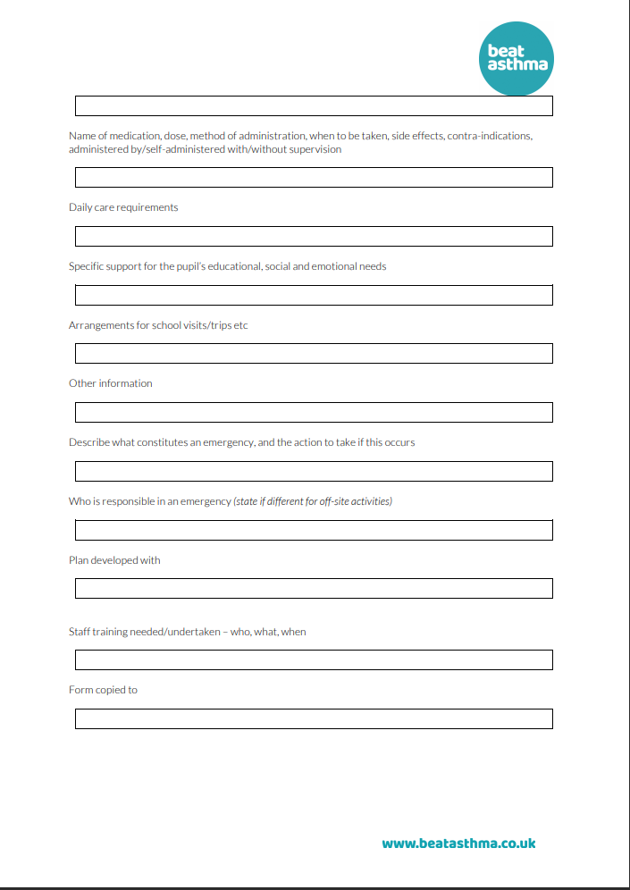

Appendix 3 Parent letter

Dear Parent

We are reviewing our asthma policy which recommends that our school keeps a asthma register for children who have asthma . We also have an emergency relief inhaler that can be used for any child within school who has a diagnosis of asthma or has been prescribed a reliever inhaler.
Your child will still need their own reliever in school which is clearly labelled with their name/expiry date and instructions/dose .
Please fill out the form below with information about your child to help us update our records .
If your child does not have a spacer or have had an asthma review in the last 12 months please arrange an appointment with your GP Practice .
Many thanks Yours sincerely

 | Please tick
I can confirm that my child has been diagnosed with asthma
I can confirm that my child has been given a reliever inhaler
I can confirm that I have supplied a reliever inhaler and spacer which is clearly labelled with my child’s name /dose and expiry date.
I have filled in the school asthma plan form and returned it to school
Please tick if you DO NOT wish your child to use the School relief inhaler in an Emergency
Print name Sign  Name of child Class/group | Date

Appendix 4 Personal asthma action plan (PAAP)
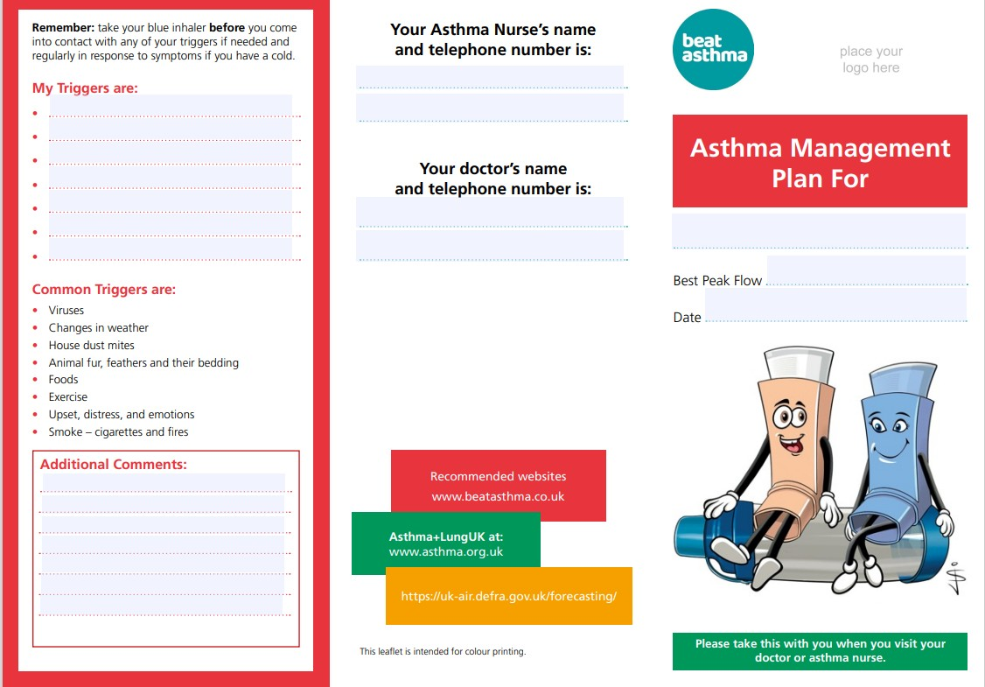
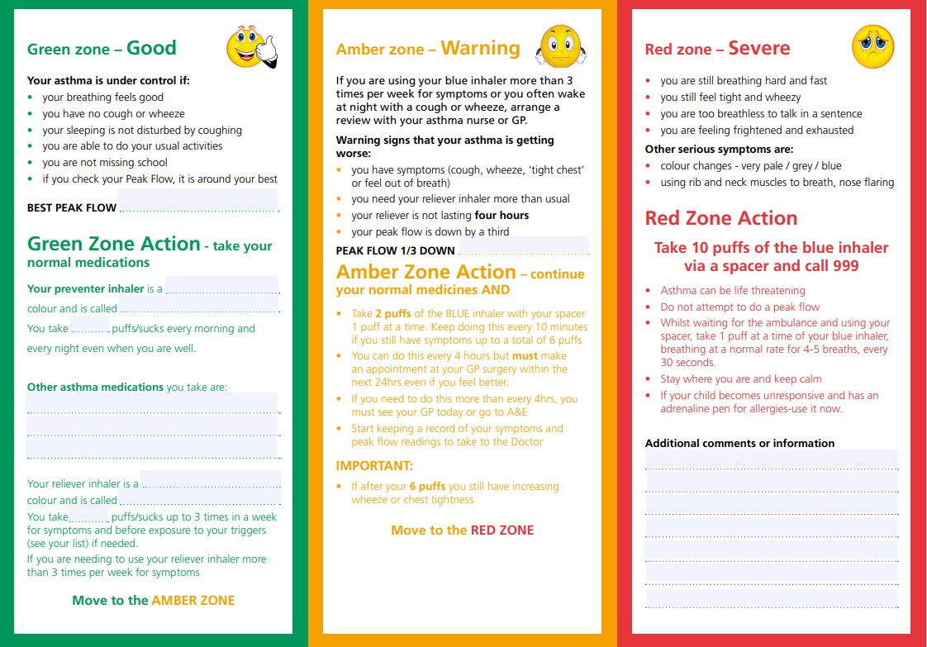

APPENDIX 5
