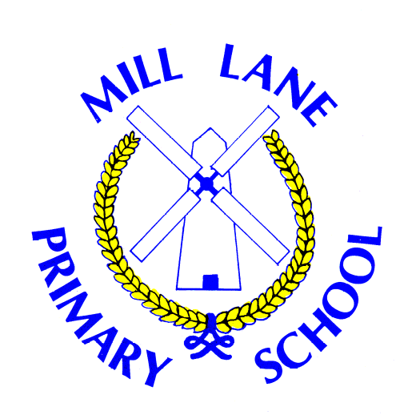
Mill Lane
Primary School

Relationships, Sex and Health Education Policy
Updated: September 2026
Updated by: Helen Forster
Date adopted by Governors and Staff: Sept 2026
Review Date: Sept 2027

Relationships Health and Sex Education (RSHE) Policy for Mill Lane Primary School

Introduction
This policy sets out the framework for Relationships, Sex and Health Education (RSHE) at Mill Lane Primary School, in line with the 2014 National Curriculum for England and current inspectorate expectations. It ensures that RSHE is delivered as part of a broad and balanced curriculum, supporting pupils’ spiritual, moral, social, and cultural development, and preparing them for life in modern society. The policy reflects statutory guidance, including the Children and Social Work Act 2017, DfE RSE Guidance (2025), Equality Act 2010, and Keeping Children Safe in Education (2026). It is designed to be inclusive, age-appropriate, and responsive to the needs of all pupils and the wider school community.
Effective RSHE is important for promoting and protecting the wellbeing of all children.

Aims
- Provide our children with the knowledge and skills required to safeguard themselves and others by equipping pupils with the skills to keep themselves safe, make healthy choices, and form positive relationships.
- Provide a safe and structured framework for discussing relationships and sex education.
- Prepare pupils for puberty and physical development.
- Promote health, hygiene, and wellbeing.
- Develop confidence, self-respect, and empathy.
- Create a positive culture around relationships, equality, and respect.
- To know what consent is and how personal boundaries should be respected.
- Teach accurate vocabulary for body parts, emotions, and relationships relating to safeguarding themselves and others (for specific vocabulary lists please refer to individual planning documents).
- Support pupils to recognise unsafe situations, manage risk, and seek help.
- Foster resilience, self-esteem, and responsible decision-making.
- Equip pupils to understand and manage online relationships and safety by being able to identify risks and influence (specifically around pressure and identity).
- To ensure all pupils, including those with SEND and from diverse backgrounds, can access and know how to be safe.

Statutory Requirements
- Relationships Education is compulsory for all primary pupils, as mandated by the Children and Social Work Act 2017.
- Biological aspects of sex education are taught through the Science curriculum (2014 National Curriculum).
- Additional, age-appropriate sex education is provided in Years 5 and 6; parents have the right to withdraw their child from this non-statutory content.
- The curriculum and policy comply with the Equality Act 2010, SEND Code of Practice 2015, and Public Sector Equality Duty.
- RSE supports the school’s safeguarding responsibilities, as required by Keeping Children Safe in Education (2026).
- The policy is reviewed annually and published on the school website.

Curriculum Coverage
Programme of Study for RSHE is within Relationships, Sex and Health Education (which covers the DfE statutory RSHE content) section of our curriculum.
The PSHE Association’s Curriculum Model for key stages 1 and 2 is designed to accompany the 2026 edition of the Programme of Study for PSHE education, which covers all of Relationships, Sex and Health education (RSHE), including statutory content for Relationships and Health Education and recommended content for Sex Education, as well as essential learning on Economic Wellbeing and Careers Education.
The Programme of Study sets out learning opportunities for each key stage and we have adapted the Curriculum Model into a tailored PSHE education curriculum for our school which provides:
- a long-term plan for the academic year across all year groups and half terms
- medium-term plans for each year group with unit outlines
- links to lesson plans (both PSHE Association resources, POL ED resources and resources carrying the Association’s Quality Mark*) that could be used to deliver each half-term unit
- additional or alternative resources that could be used to enhance each half-term unit
New PSHE Association and quality assured lesson plans will be added to the Curriculum Model as they are published.
Children will be explicitly taught safeguarding vocabulary (for specific lists see individual lesson plans).
At Mill Lane, SMSC (Spiritual, Moral, Social, and Cultural) is embedded across our curriculum. SMSC is a framework used in UK education to promote the holistic, personal development of students. In our school, it is embedded across our curriculum to help pupils become well-rounded, tolerant, and active citizens.
The Four Pillars of SMSC
- Spiritual: Developing a sense of self, personal beliefs, imagination, creativity, and a sense of awe and wonder about the world.
- Moral: Understanding right from wrong, respecting the law, recognising the consequences of actions, and investigating moral and ethical issues.
- Social: Developing interpersonal skills, understanding how communities work, participating in volunteering or community events, and resolving conflicts.
- Cultural: Appreciating diverse cultural traditions, understanding Britain's cultural heritage, and showing respect for those with different faiths and beliefs.
How we deliver SMSC
- Integrated Curriculum: It is woven into Personal, Social, Health, and Economic (PSHE) education and Religious Education (RE).
- Whole-School Ethos: It is promoted daily through assemblies, student councils, charitable initiatives, and peer support.
- Fundamental British Values: SMSC serves as the vehicle through which we actively promote democracy, the rule of law, individual liberty, and mutual tolerance.
Excellent provision helps us to demonstrate that we are keeping children safe, promoting positive behavior, and preparing them for life in modern Britain.
The curriculum is designed as a spiral programme, revisiting key concepts at increasing levels of depth and complexity. In the Early Years Foundation Stage (EYFS), PSHE is delivered through Personal, Social and Emotional Development (PSED), focusing on self-regulation, managing self, and building relationships.

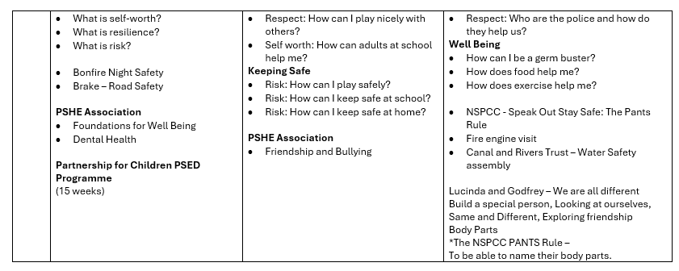
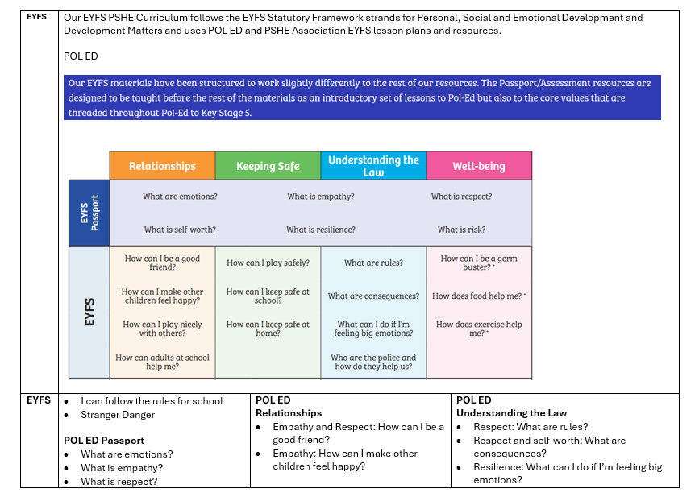

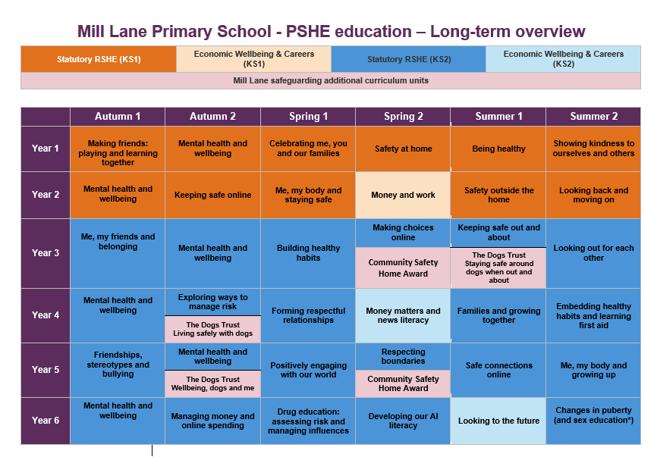

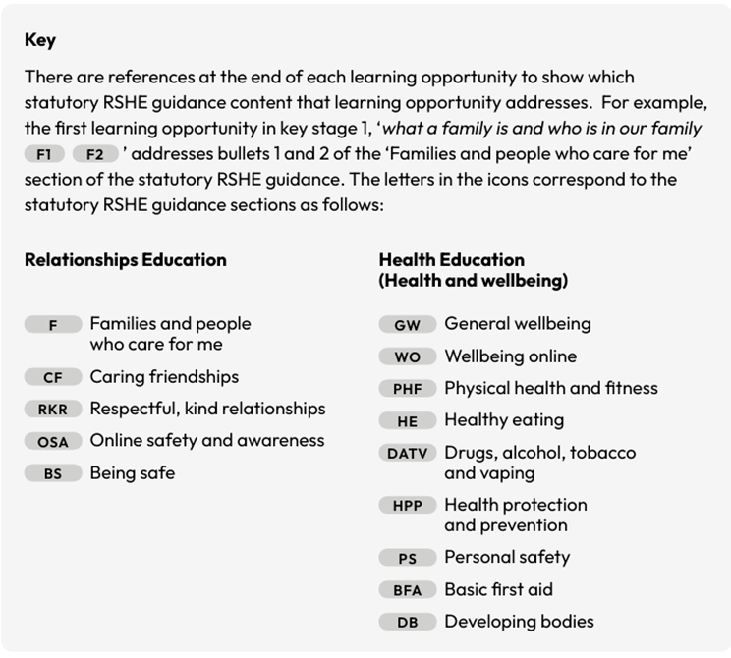

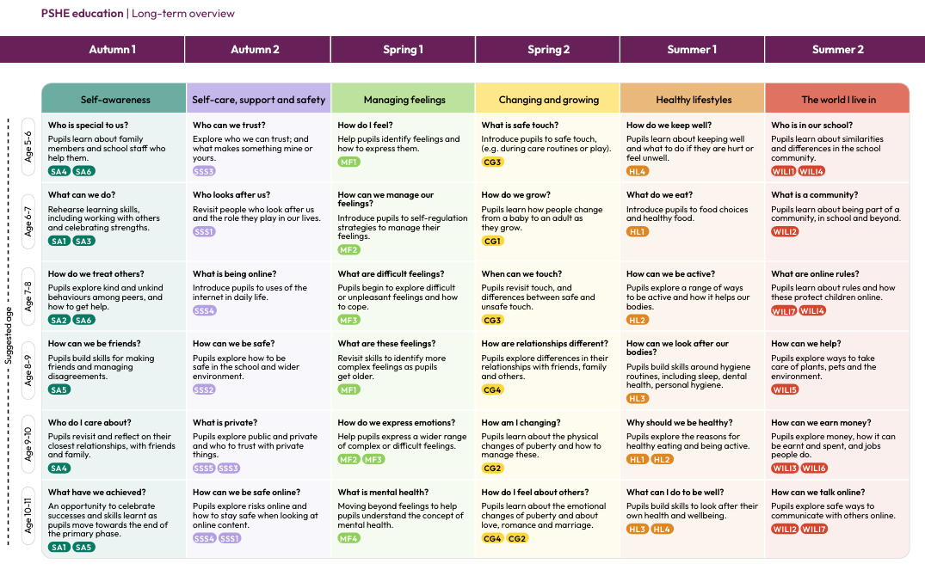

The Mill Lane Primary School Curriculum map can be found here.

PSHE and RSHE | Mill Lane Primary
- Relationships Education covers:
  - Families and people who care for me
  - Caring friendships
  - Respectful, kind relationships
  - Online relationships Online safety and awareness
  - Being safe (including safe relationships, consent, boundaries and trust)
- Health Education (Health and wellbeing)
  - General wellbeing
  - Wellbeing Online
  - Physical Health and Fitness
  - Healthy Eating
  - Drugs, alcohol, tobacco and vaping
  - Health protection and prevention
  - Personal safety
  - Basic first aid
  - Developing bodies
- Sex Education (beyond statutory science) includes:
DfE statutory guidance recommends that ‘primaries teach sex education in years 5 and/or 6, in line with content about conception and birth, which forms part of the national curriculum for science’. There is therefore a suggested learning opportunity on the processes of reproduction and birth below, for schools that choose to provide age-appropriate Sex Education in key stage 2
  - Puberty and physical changes is now within ‘Health - Developing Bodies’ (see below from PSHE PoStudy) Parents and carers are not permitted to withdraw their children from these lessons.
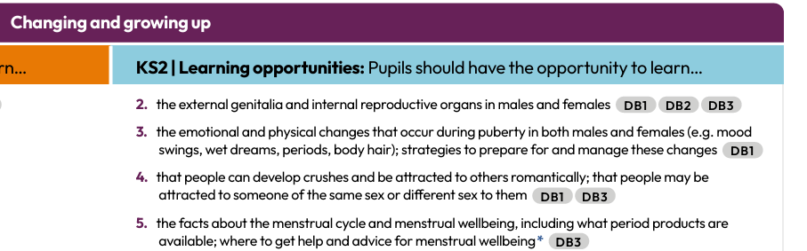

  - Human life cycles and reproduction (age-appropriate, in upper Key Stage 2) is this now called ‘Sex Ed’ and is within the Changing and Growing Up unit (p14 of PoStudy) See below. Parents and carers are permitted to withdraw their children from these lessons when taught.

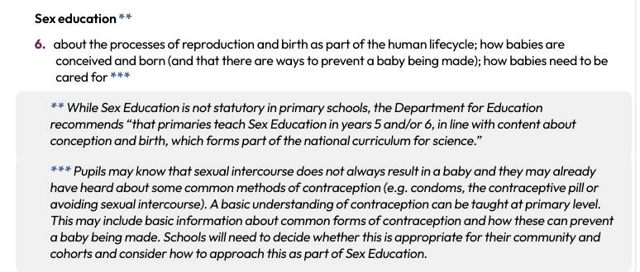

Mill Lane Primary School teach the Medway: Changing and Growing Up lessons 1-3 as part of the PSHE Associations units Changes in Puberty (and sex education*).
Medway: Changing and growing up – Y6
L1: Puberty recap
L2: Puberty – change and becoming independent
L3: Positive, healthy relationships

Medway lesson 4 How a baby is made is not on the agreed MLPS PSHE curriculum and is therefore not taught.
*The parental right to withdraw applies to sex education (Medway lesson 4) so right to withdraw does not apply to any MLPS PSHE curriculum lessons

- Science Curriculum includes:
  - Naming body parts
  - Human development and reproduction
  - Changes during puberty
- Personal Development (this incorporated into other aspects of the programme of study)
  - Emotional literacy, empathy, and managing feelings
  - Recognising and reporting abuse, including online
  - Understanding diversity, equality, and different family structures
- Skills Progression:
  - Communication, self-awareness, and decision-making
  - Building and maintaining positive relationships
  - Staying safe in different contexts
  - Understanding risks

Curriculum Implementation
- RSE is delivered through a spiral curriculum within PSHE, Science, and RE, revisiting key concepts at increasing levels of depth.
- Lessons are coherently planned, sequenced, and adapted to meet the needs of all pupils, including those with SEND and EAL.
- Teaching approaches include:
  - Active learning (discussion, role-play, scenarios, problem-solving)
  - Use of accurate, age-appropriate safeguarding vocabulary
  - Establishment of clear ground rules and a respectful learning environment
  - Adaptations and differentiation to ensure accessibility for all pupils
- The curriculum reflects the diversity of families, relationships, identities and experiences within the school community.
- Ground rules are established to create a safe and respectful learning environment, enabling open discussion of sensitive topics. Where appropriate, lessons may require the use of our ‘Ask it baskets’ to ensure children are confident or know how to ask questions they may not want to ask in whole class scenarios.
- Safe discussion protocols agreed and used by all staff. Teachers may defer or adapt response to handle difficult questions, eg ‘That is a really good questions, that will be answered when you are older,’ and ‘You may want to ask your parents that question as it isn’t appropriate for me to answer it in this lesson.’
- Children will be taught that teachers cannot guarantee confidentiality and will respond in line with safeguarding policies and procedures. Disclosures will be referred to designated safeguarding leads – following school policy.
- The curriculum is adapted and differentiated to meet the needs of all pupils, including those with SEND and from diverse backgrounds.
- External visitors and agencies are used to enhance learning, with careful management and safeguarding checks, for example, school nurse, toothbrushing professional etc.
- Pupil voice is embedded through opportunities to contribute to curriculum design, evaluation, and school life.
- Parents are informed of RSHE content in advance and can view teaching materials upon request.

The Mill Lane Primary School Curriculum map can be found here.

PSHE and RSHE | Mill Lane Primary

Assessment
- Ongoing formative assessment is used to check understanding, inform teaching, and support pupil progress (e.g., discussion, reflection, pupil voice, self-assessment).
- There is no statutory summative assessment, but evidence of learning is gathered through work scrutiny, observation, and pupil feedback. At Mill Lane Primary School, we guided by the PSHE Associations assessment criteria. Using the outcome statements children will be assessed as working towards, working at or working beyond within each unit. Teachers will then use the statements to assess, plan and review future learning.
- Assessment outcomes are used to adapt planning and ensure all pupils make progress in knowledge, understanding, and skills.
- Pupil voice is regularly sought to evaluate the impact of RSHE provision.

Roles and Responsibilities
Role | Responsibilities
Governing Body | Approves and monitors the RSHE policy; ensures statutory compliance
Headteacher | Ensures consistent delivery; manages parental requests for withdrawal
PSHE Lead | Oversees curriculum planning, delivery, and monitoring; supports staff training
Teaching Staff | Deliver RSHE sensitively and inclusively; monitor progress; maintain safe environment
Pupils | Engage respectfully; contribute to a positive learning environment
Parents/Carers | Engage with the policy; support learning at home; communicate with school

Inclusion
- The RSHE curriculum is inclusive and accessible to all pupils, regardless of sex, race, disability, religion or belief, sexual orientation, or family background.
- Content and delivery are adapted for pupils with SEND, in line with the SEND Code of Practice.
- Teaching reflects the diversity of families and relationships, challenging stereotypes and promoting equality.
- Materials and activities are differentiated to meet varying needs and abilities.
- Cultural and religious backgrounds are respected, and reasonable adjustments are made where appropriate.

Professional Development
- All staff receive induction and ongoing professional development in RSHE, including subject knowledge, pedagogy, and handling sensitive issues. This is often through PSHE Association online or by the PSHE Lead.
- Training includes safeguarding procedures and the use of accurate, age-appropriate vocabulary.
- External professionals may support staff training and curriculum delivery.
- Staff are supported to develop confidence and consistency in delivering RSHE.

Inspectorate Expectations
- The RSHE curriculum is coherently planned, sequenced, and ambitious for all pupils, including those with SEND and disadvantaged backgrounds.
- Provision is age-appropriate, inclusive, and reflects the needs and backgrounds of the school community.
- The curriculum intent, implementation, and impact are clearly articulated and evidenced.
- RSHE contributes to pupils’ spiritual, moral, social, and cultural development and prepares them for life in modern Britain.
- A safe, respectful, and inclusive learning environment is maintained, with clear ground rules for sensitive discussions.
- Leadership ensures compliance with statutory guidance, stakeholder consultation, and effective safeguarding.
- Robust systems are in place for assessment, monitoring, and evaluation of RSHE provision.

Monitoring and Review
- The RSHE policy and curriculum are reviewed annually or following updates to statutory guidance.
- Monitoring activities include work scrutiny, learning walks, lesson observation, and gathering pupil voice.
- Findings are used to inform ongoing improvement and are reported to school leaders and governors.
- Stakeholders, including parents, pupils, staff, and governors, are consulted as part of the review process.
- The policy is accessible to all stakeholders via the school website Policies | Mill Lane Primary

Links to Other Policies
- Safeguarding and Child Protection Policy
- Behaviour Policy
- Anti-Bullying Policy
- Equality and Diversity Policy
- SEND Policy
- PSHE Policy
- Online Safety Policy
- Science Curriculum Policy

