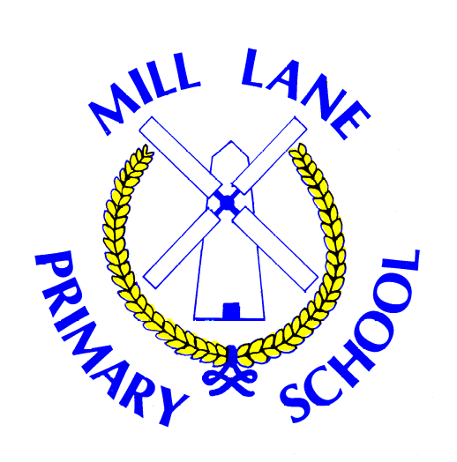

Mill Lane
Primary School

PSHE Policy

Updated: September 2026
Updated by: Helen Forster
Date adopted by Governors and Staff: Sept 26
Review date: Sept 27

PSHE Policy for Mill Lane Primary School

Introduction
This policy outlines the provision of Personal, Social, Health and Economic (PSHE) education at Mill Lane Primary School, in line with the 2014 National Curriculum framework and statutory guidance for Relationships and Health Education. PSHE is central to our school’s ethos and supports the development of pupils’ personal, social, emotional, and economic wellbeing. The policy reflects national inspectorate expectations, including those of Ofsted, and ensures a broad, balanced, and inclusive curriculum that prepares pupils for life in modern Britain.
Personal, Social, Health and Economic (PSHE) education is the school subject through which pupils develop the knowledge, skills, attributes and agency they need to manage their lives, now and in the future. It helps children and young people to stay healthy and safe, while preparing them to make the most of their lives and careers.

Aims
- To provide our children with the knowledge and skills required to safeguard themselves and others by equipping pupils with the skills to keep themselves safe, make healthy choices, and form positive relationships.
- To provide a planned, progressive PSHE curriculum that develops pupils’ knowledge, skills, and attributes for lifelong wellbeing.
- To support pupils’ spiritual, moral, social, and cultural development, including the promotion of British Values.
- To allow for learning opportunities to ‘manage’ or ‘respond to’ challenging situations. These terms are used to describe strategies which, depending on the context, might include: being able to identify risks or warning signs; resisting internal or external pressures; making informed decisions; exit strategies for unsafe situations; and knowing whom, how and when to ask for help, including reporting concerns.
- To foster resilience, self-regulation, empathy, and active citizenship.
- To ensure all pupils, including those with SEND and from diverse backgrounds, can access and succeed in PSHE.
- To embed PSHE across the whole school, supporting safeguarding and pupil voice.

Statutory Requirements
- Deliver personal, social, health and relationships education as set out in DfE statutory guidance (2025).
- Teach PSHE in a way that supports the Equality Act 2010 and SEND Code of Practice (2015), ensuring accessibility and inclusivity.
- Promote safeguarding by enabling pupils to recognise and report abuse, understand consent, and stay safe online (Keeping Children Safe in Education 2023).
- Provide a broad and balanced curriculum that prepares pupils for the opportunities, responsibilities, and experiences of later life (Education Act 2002).
- Consult parents on PSHE policy and inform them about curriculum content.
- Ensure a safe environment for all PSHE activities, including risk assessments for sensitive topics and external visitors, when required.

Curriculum Coverage
Programme of Study is divided into two main sections:
- Relationships, Sex and Health Education (which covers the DfE statutory RSHE content)
- Economic Wellbeing and Careers Education, with the learning opportunities for each key stage organised under subheadings within each section.
The statutory RSHE guidance includes aspects of financial education, in particular content relating to financial harms such as gambling, chance based transactions in gaming, scams, and money laundering. But these topics cannot be effectively taught without the foundational learning in personal finance that is at the heart of ‘Economic Wellbeing’.

The PSHE Association’s Curriculum Model for key stages 1 and 2 is designed to accompany the 2026 edition of the Programme of Study for PSHE education, which covers all of Relationships, Sex and Health education (RSHE), including statutory content for Relationships and Health Education and recommended content for Sex Education, as well as essential learning on Economic Wellbeing and Careers Education.
The Programme of Study sets out learning opportunities for each key stage and we have adapted the Curriculum Model into a tailored PSHE education curriculum for our school which provides:
- a long-term plan for the academic year across all year groups and half terms
- medium-term plans for each year group with unit outlines
- links to lesson plans (both PSHE Association resources, POL ED resources and resources carrying the Association’s Quality Mark*) that could be used to deliver each half-term unit
- additional or alternative resources that could be used to enhance each half-term unit
New PSHE Association and quality assured lesson plans will be added to the Curriculum Model as they are published.
Children will be explicitly taught safeguarding vocabulary (for specific lists see individual lesson plans).
At Mill Lane, SMSC (Spiritual, Moral, Social, and Cultural) is embedded across our curriculum. SMSC is a framework used in UK education to promote the holistic, personal development of students. In our school, it is embedded across our curriculum to help pupils become well-rounded, tolerant, and active citizens.
The Four Pillars of SMSC
- Spiritual: Developing a sense of self, personal beliefs, imagination, creativity, and a sense of awe and wonder about the world.
- Moral: Understanding right from wrong, respecting the law, recognising the consequences of actions, and investigating moral and ethical issues.
- Social: Developing interpersonal skills, understanding how communities work, participating in volunteering or community events, and resolving conflicts.
- Cultural: Appreciating diverse cultural traditions, understanding Britain's cultural heritage, and showing respect for those with different faiths and beliefs.
How we deliver SMSC
- Integrated Curriculum: It is woven into Personal, Social, Health, and Economic (PSHE) education and Religious Education (RE).
- Whole-School Ethos: It is promoted daily through assemblies, student councils, charitable initiatives, and peer-mentoring programs.
- Fundamental British Values: SMSC serves as the vehicle through which we actively promote democracy, the rule of law, individual liberty, and mutual tolerance.
Excellent provision helps us to demonstrate that we are keeping children safe, promoting positive behavior, and preparing them for life in modern Britain.
The curriculum is designed as a spiral programme, revisiting key concepts at increasing levels of depth and complexity. In the Early Years Foundation Stage (EYFS), PSHE is delivered through Personal, Social and Emotional Development (PSED), focusing on self-regulation, managing self, and building relationships.

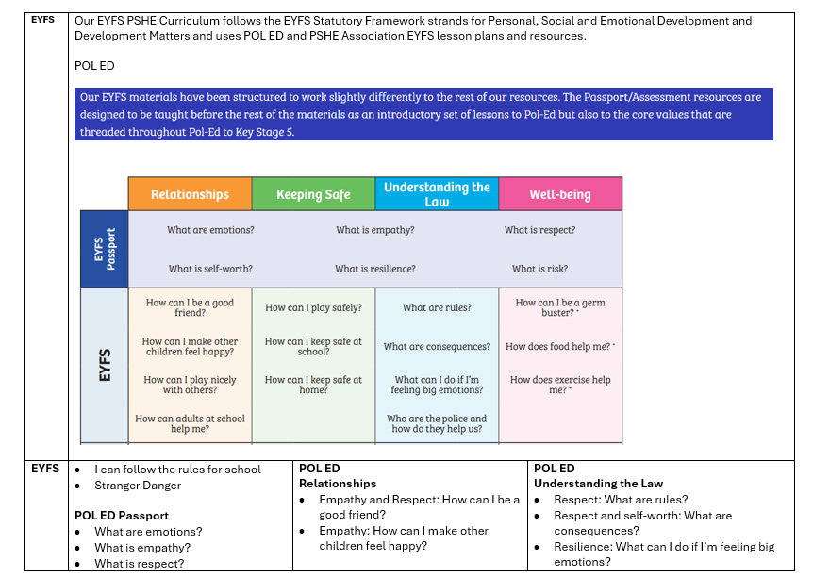
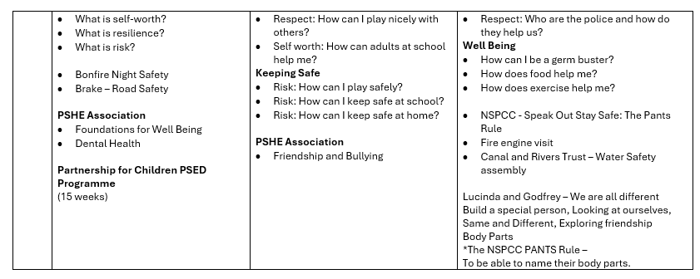

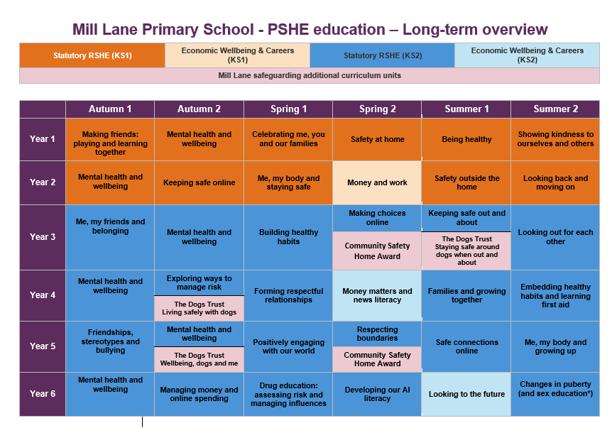

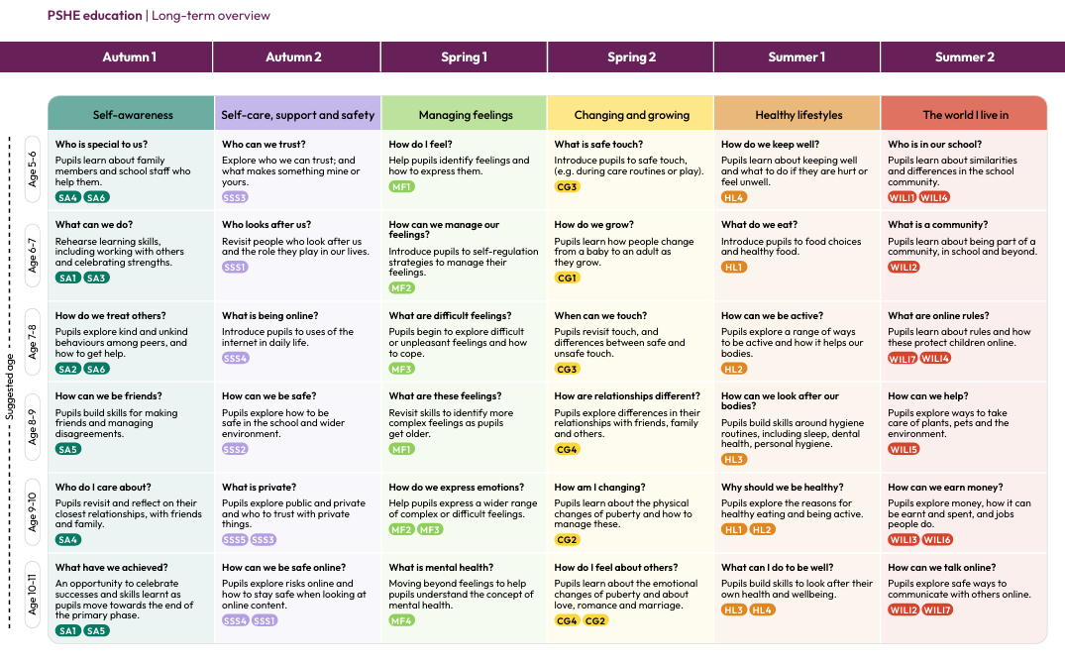

The Mill Lane Primary School Curriculum map can be found here.

PSHE and RSHE | Mill Lane Primary

Curriculum Implementation
- The PSHE curriculum is coherently planned and sequenced to ensure progression in knowledge, skills, and understanding.
- Weekly PSHE lessons are delivered by class teachers, supplemented by assemblies, themed days, and enrichment activities.
- Teaching approaches include discussion, role play, collaborative learning, and real-life scenarios to promote active engagement and pupil voice.
- Ground rules are established to create a safe and respectful learning environment, enabling open discussion of sensitive topics. Where appropriate, lessons may require the use of our ‘Ask it baskets’ to ensure children are confident or know how to ask questions they may not want to ask in whole class scenarios.
- Safe discussion protocols agreed and used by all staff. Teachers may defer or adapt response to handle difficult questions, eg ‘That is a really good questions, that will be answered when you are older,’ and ‘You may want to ask your parents that question as it isn’t appropriate for me to answer it in this lesson.’
- Children will be taught that teachers cannot guarantee confidentiality and will respond in line with safeguarding policies and procedures. Disclosures will be referred to designated safeguarding leads – following school policy.
- The curriculum is adapted and differentiated to meet the needs of all pupils, including those with SEND and from diverse backgrounds.
- External visitors and agencies are used to enhance learning, with careful management and safeguarding checks, for example, history actors, musicians, athletes, music/chess/PE teachers etc.
- Pupil voice is embedded through opportunities to contribute to curriculum design, evaluation, and school life.

Assessment
- Assessment in PSHE is ongoing and formative, focusing on pupils’ participation, reflection, and application of learning.
- Teachers use observation, questioning, self-assessment, and pupil reflection to monitor progress in knowledge, skills, and attitudes.
- Evidence of learning is recorded through class discussions, written work, contributions to school and community activities, on Evidence Me and class floor books.
- There are no statutory attainment targets; assessment is used to inform planning and support individual development. At Mill Lane Primary School, we guided by the PSHE Associations assessment criteria. Using the outcome statements children will be assessed as working towards, working at or working beyond within each unit. Teachers will then use the statements to assess, plan and review future learning.
- Progress is demonstrated through positive behaviour, participation, and the development of key skills such as resilience, decision-making, and empathy.

Roles and Responsibilities
Role | Responsibilities
PSHE Lead | Oversees curriculum planning, monitoring, evaluation, and staff development.
Class Teachers | Deliver PSHE lessons, adapt content for pupil needs, assess progress, and create a safe environment.
Senior Leadership | Ensure PSHE is prioritised, resourced, and embedded across school life.
All Staff | Model positive relationships, support PSHE values, and contribute to a whole-school approach.
External Visitors | Enhance curriculum delivery under the supervision of school staff and in line with safeguarding.

Inclusion
- The PSHE curriculum is accessible to all pupils, including those with SEND and from disadvantaged or minority backgrounds.
- Lessons are differentiated and adapted to meet individual needs, with reasonable adjustments as required.
- Content reflects the diversity of the school community and promotes equality of opportunity.
- Resources and teaching approaches are selected to ensure representation and avoid stereotypes.
- Pupil voice is actively sought to ensure relevance and engagement for all learners.

Professional Development
- All staff receive regular, high-quality continuing professional development (CPD) in PSHE, including updates on statutory guidance and best practice. This is often through PSHE Association online or by the PSHE Lead.
- Training covers effective teaching of sensitive topics, inclusion, safeguarding, and assessment in PSHE.
- The PSHE Lead provides ongoing support, resources, and opportunities for staff to share practice and reflect on provision.
- New staff receive induction on the PSHE policy and curriculum.

Inspectorate Expectations
This policy ensures compliance with national inspectorate expectations by:
- Providing a well-structured, sequenced, and age-appropriate PSHE curriculum.
- Embedding PSHE across the curriculum and wider school life, supporting SMSC development and British Values.
- Ensuring safeguarding is integral to PSHE, including online safety and recognising/reporting abuse, including explicitly teaching safeguarding vocabulary.
- Making the curriculum accessible and inclusive for all pupils, with evidence of adaptation and differentiation.
- Promoting active learning, pupil voice, and engagement.
- Implementing effective systems for monitoring, evaluation, and continuous improvement.

Monitoring and Review
- The PSHE Lead monitors curriculum delivery, pupil outcomes, and staff training needs through lesson observations, planning scrutiny, and pupil feedback.
- The effectiveness of PSHE provision is evaluated annually, with input from staff, pupils, and parents.
- The policy is reviewed every year in line with the RSHE policy, or sooner if required by updates to statutory guidance or school priorities.
- Outcomes from monitoring inform curriculum development and staff CPD.

Links to Other Policies
- Safeguarding and Child Protection Policy
- Relationships, Sex and Health Education (RSHE)
- Behaviour Policy
- Anti-Bullying Policy
- Equality and Diversity Policy
- SEND Policy
- Online Safety Policy
- Curriculum Policy
Policies | Mill Lane Primary

