Mill Lane
Primary School

Mill Lane Minis and Nursery Admissions
Policy

Date updated: May 2026 by Claire Douglas
Written by: Samantha Lee
Date adopted by Governors and Staff: May 2026
Review Date: May 2028

Places and Allocation

At Mill Lane we run a 10 place 2 year old provision called Mill Lane Minis. Children attend for 5 sessions a week during a morning session. Depending on staff capacity we are also able to offer 10 places during an afternoon session, if needed. We also have a 26 place Nursery where children attend for 5 sessions per week, either in the morning or the afternoon or all day. The 30 hour provision offer is arranged on an individual basis with parents who are entitled for up to 5 children.

Session times currently run as follows:
Morning 8:45am – 11:45am
Afternoon 12:30pm – 3:30pm

Wherever possible older children attend during the morning session. This enables the curriculum to be further tailored to meet the needs of all pupils, enabling staff to ensure that older pupils are school ready before their transition into a Reception Class.

If sessions in Minis or in Nursery are at capacity, a waiting list for places is kept by Nursery staff and places are allocated in age order as soon as possible following their 2nd or 3rd birthday. If older children apply for a Nursery place, these are allocated as soon as a place becomes available.

Home Visits and Transitions

Staff aim to complete a home visit for every child before they begin at Mill Lane Nursery. This gives staff the opportunity to meet the child in a familiar environment, meet parents/carers and answer any questions they may have.

During the home visit, paperwork is completed so staff can gather information which will make a child’s transition into school easier, including what they like to play with, if they are toilet trained and if they like milk, for example.

If a child has attended a previous setting, staff ask permission during the home visit to contact that setting and share information about the child. Any additional transition activities that may be appropriate including visits with a Key Person over time can be arranged. This is also an opportunity for any additional needs including SEND or Safeguarding information to be highlighted. The Stockton LA “Moving Forward” document is requested from the child’s previous setting if it is not automatically received.

During a home visit each child will be given a visit date. On this date they will visit the setting for approximately 30 minutes with a parent/carer to become familiar with the environment and see staff in the setting. The following day is the child’s start date. On their start date the child will stay without a parent/carer for one hour in the setting. The session lengths are then built up at a pace that meets the needs of each individual child, building confidence and ensuring they feel happy and secure.

Application

Application forms for Minis and Nursery are available from the school office (Appendix 1). When these are completed they are filed in Nursery and contact will be made as soon as a place is available following the child’s 2nd or 3rd Birthday. Application forms are also available via our school website and can be completed online.
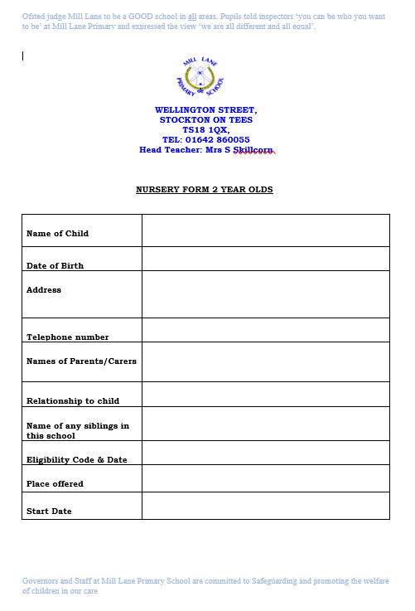
Appendix 1

Appendix 2
