Pupil premium strategy statement for Mill Lane Primary School

This statement details our school’s use of pupil premium (and recovery premium for the 2024 to 2025 academic year) funding to help improve the attainment of our disadvantaged pupils.

It outlines our pupil premium strategy, how we intend to spend the funding in this academic year and the effect that last year’s spending of pupil premium had within our school.

School overview
Detail | Data
School name | Mill Lane Primary School
Number of pupils in school | 243
Proportion (%) of pupil premium eligible pupils | 58.85%
Academic year/years that our current pupil premium strategy plan covers | 2025-2026
Date this statement was published | 01 September 2025
Date on which it will be reviewed | 31 August 2026
Statement authorised by | Sue Skillcorn
Pupil premium lead | Sue Skillcorn
Governor | John Taylor
Funding overview
Detail | Amount
Pupil premium funding allocation this academic year | £183,315
Recovery premium funding allocation this academic year | £0
Matched funding from school budget | £0
Pupil premium funding carried forward from previous years (enter £0 if not applicable) | £0
Total budget for this academic year  If your school is an academy in a trust that pools this funding, state the amount available to your school this academic year | £183,315

Part A: Pupil premium strategy plan

Statement of intent
All members of staff and the governing body accept responsibility for ‘socially disadvantaged’ pupils and are committed to meeting their pastoral, social and academic needs within a caring and nurturing environment. We hope that each child will develop a love for learning and acquire skills and abilities commensurate with fulfilling their potential throughout their education and as an adult finding employment. The current pupil premium strategy plan works towards achieving these objectives by poverty proofing the school in order to offer educational opportunities and life experiences to enable children to reach or exceed age related expectation. The key principal of Mill Lane Primary School’s Strategy Plan is to reduce barriers to enable every child to reach his or her full potential.
Our Philosophy and Principles
We are fully committed to providing opportunities for all pupils to succeed and to provide the necessary interventions to ensure that success is experienced by all. We ensure that
- Teaching and learning opportunities meet the needs of all pupils
- Appropriate provision is made for pupils who belong to vulnerable groups, this includes ensuring that the needs of disadvantaged pupils are adequately assessed and addressed
- we recognise that not all pupils who receive free school meals will be disadvantaged
- We also recognise that not all pupils who are disadvantaged are registered or qualify for free school meals
- We reserve the right to allocate the Pupil Premium funding to support any pupil or groups of pupils the school has legitimately identified as being disadvantaged
- Pupil premium funding will be allocated following data analysis and pupil progress meetings which identify priority classes, groups or individuals.
- Children experience quality first teaching, meeting the needs of each individual child
- Every child reaches or exceeds age-related expectations in reading, writing and mathematics
- No child is disadvantaged due to inability to pay for school trips, residential visits, music tuition or other extra-curricular activities
- Pupil Premium funding is allocated after a needs analysis and exploration of what research tells us to provide the most appropriate support and intervention for pupils

Challenges

This details the key challenges to achievement that we have identified among our disadvantaged pupils.
Challenge number | Detail of challenge
1 | Social: Low aspiration, poor nutrition/hunger, family aspiration/expectation, poor health, family engagement, cultural capital.
2 | Emotional: Emotional health and well-being, low self-esteem, resilience, confidence
3 | Behavioural: Behaviour for learning, attendance
4 | Cognitive: Communication, language and literacy, EAL, vocabulary range, progress in core curriculum, academic achievement, early intervention, Special Educational Needs. Low starting points
5 | NHS waiting lists are long for specialists such as the Speech and language Therapists and Occupational Therapists.
IMPACT/MEASUREMENT
Social
- Pupil voice
- Data taking up breakfast offer
- Attendance at parent consultations
- Attendance at engagement opportunities including annual visit
- Participation data
Emotional
- Pupil voice
- Progress and attainment data
- Parent/Carer voice
- Staff voice
Behavioural
- Progress and attainment data
- Attendance data

Cognitive
- Progress and attainment data

BARRIERS IDENTIFIED THROUGH:
- Learning walks
- Pupil Premium student shadowing
- Pupil Premium student voice
- Achievement analysis
- Attendance and punctuality analysis
- Attendance at curriculum enrichment
activities
- Incident report analysis
- Attendance at parent/carer consultations
- Children, parent, SLT, staff and governor
views
- Observational assessments
- Work scrutinies
- Poverty Proofing Report
- Debating Society
- IDACI

Attainment on Entry | Majority enter nursery at least a year behind development milestones in 10 / 17 areas. 0% in writing (W), 5% in number (N), 5% in Number and Numerical Patterns (NNP)and 12% in Reading (R) enter nursery at age related expectation (ARE) of 30-50 months (m).  33% in W, 63% in N, 63% in NNP and 41% in R enter nursery significantly below ARE (16-26m and below). No children enter above ARE (40-60 m)
Ethnicity/EAL | 59% EAL  34 ethnic groupings  34 languages spoken  18% (Almost 1 in 5) Significant number of refugees, asylum seekers, or Indefinite Leave to Remain
Stability | High mobility: 48 transfers in 2024-25 therefore progress data is not always comparing the same children. Many children start Mill Lane having just arrived in the country and speaking no English, make outstanding progress across the curriculum, but leave the area when they receive Leave to Remain.

School Profile | 243 including nursery
Community Served | 59% Pupil Premium  51% boys, 49% girls  59% EAL  36% SEND, 4 HNF, 18 EHCPs. We will apply for 6 more EHCPs and have applied for another one HNF. We are gathering evidence for a further 2 HNFs.
LACYP | 5 Children in our Care
Family Demographics | 88% (almost 9 out of 10) in lowest 15%, and 7 out of 10 are in lowest 5% of deprivation in the country. This has increased by 27% in the last 5 years.  2 CP, 3 EH, 12CIN  5 Families access counselling
Attendance  2024-25 | 93.5% including Extended Leave & Religious Observance  National Average was 94.8%

Sept 25

Intended outcomes
This explains the outcomes we are aiming for by the end of our current strategy plan, and how we will measure whether they have been achieved.
Intended outcome | Success criteria
Academic achievement | Improved outcomes and the gap to National Others will be further closed.
Improved attendance | Persistent absence will improve to close the gap to with national average.
Participation | A poverty proofed school with enthusiastic children who are motivated to learn.
Improved resilience, emotional health and well-being | Happy and emotionally healthy children who are resilient and successful.

Dates of Pupil Premium Reviews 5th November 2025
4th February 2026
17th June 2026

Activity in this academic year
This details how we intend to spend our pupil premium (and recovery premium funding) this academic year to address the challenges listed above.

Teaching (for example, CPD, recruitment and retention)
Budgeted cost: £29,758
Activity | Evidence that supports this approach | Challenge number(s) addressed
Identified CPD to ensure quality first teaching and intervention | Assessment and identification for provision mapping leading to improved outcomes  Higher Achievement Research Transforming Tees | 4  £1,447  £3,000
Termly RWI Consultant support to ensure that phonics teaching is high quality and effective | RWI outcomes  Education Endowment Foundation | 4  £3,360
Teacher release time for monitoring and coaching | Education Endowment Foundation | 3  £14,376
The employment of an additional Speech and Language Therapist | Barrier to learning  Education Endowment Foundation | 5  59% x £7,680 = £4,531
The allocation of an Educational Psychologist to ensure faster access to services | Barrier to learning  Education Endowment Foundation | 5  59% x £5,160 = £3,044

Targeted academic support (for example, tutoring, one-to-one support structured interventions)
Budgeted cost: £106,033
Activity | Evidence that supports this approach | Challenge number(s) addressed
The employment of an additional teacher employed to deliver interventions to KS2 (RC) | Improved KS2 data outcomes  Education Endowment Foundation | 4  £32,116 ÷ 156 (52wksx3days) = £205.87 x 52 weeks = £10,705
The employment of an additional teacher employed to deliver intervention (RC) | Improved KS1 data outcomes  Education Endowment Foundation | 4  59% x £73,492 =  £43,630
The employment of an additional TA 0.5 in EY to enable children to be taught in small groups (NR) | Improved EY data outcomes  Education Endowment Foundation  Yearly Years Toolkit | 4  59% x £23,733 ÷ 2 =  = £14,002
The employment of 0.5 TA (NR) to allow delivery the Early Talk Boost Language programme | Data, discussion and observation  Education Endowment Foundation | 4  £23,733 ÷ 2 =  £14,002
Mid-day supervisors’ overtime to support 1:1 reading (BRP trained) | Data, discussion and observation  What Works Well Clearinghouse | 4  59 x £19,000 ÷ 47% =  £11,210
TA support for EAL pupils (MA / JW) | Data, discussion and observation  What Works Well Clearinghouse | 4  £14.98 an hour x 36 wks = £539 x 4 chn = £2,156
TA provision of Occupational Therapy to support physical development and learning (OT / SL) | Data, discussion, OT reports and observation  What Works Well Clearinghouse | 1  £14.98 an hour x 2.5 hrs a week x 36 wks = £1,348 x 2 TAs = £2,696
Reading Plus reading intervention programme | Data, discussion and observation  Education Endowment Foundation | 4  £24 x 150 chn = £3,600
PiXL assessment, therapy and intervention programme | Data, discussion and observation  Education Endowment Foundation | 4  £2,700
Lexia reading support programme | Data, discussion and observation  Education Endowment Foundation | 4  £1,230
Times Tables Rock Stars | Data, discussion and observation  Education Endowment Foundation | 4  £102

Wider strategies (for example, related to attendance, behaviour, wellbeing)
Budgeted cost: £47,524
Activity | Evidence that supports this approach | Challenge number(s) addressed
Incentives to improve attendance | Attendance data  What Works Well Clearinghouse | 3  £500
PSA to address attendance and punctuality issues | Attendance data  What Works Well Clearinghouse | 3  £2,619
PSA critical attendance focus 4 mornings a week | Attendance data  What Works Well Clearinghouse | 3  £4,619
Subsidise parental contributions to enable all children to access curriculum enrichment activities including educational visits, theatre visits and residential opportunities to develop Cultural Capital | Participation and equality  Poverty Proofing North East | 2  £7281
Purchase uniform sweatshirts, PE Kits, water bottles and Book bags | Equality  Poverty Proofing North East | 2  £9,520
Chess, Music and ICT specialist teaching | Participation and equality  Poverty Proofing North East | 4  £7,201
Parent Support Advisor to work with our more vulnerable families on: Attendance, Safeguarding and Emotional well-being | Data, meetings and discussions  DfE | 4  £4,619
Provide a family counselling service for vulnerable pupils to enable a greater range and depth of issues faced by children and families to be tackled | Observation and discussion  DfE | 2  £5,379
Provide milk and butter for the daily free breakfast for children and to provide free fruit for KS2 children | Health and discussions  British Nutrition Foundation | 1  £1,692
Staff to deliver breakfast club (GV & TAs) | Health and discussion  British Nutrition Foundation | 1  £4,094

Total budgeted cost: £183,315
The Pupil Premium grant is a government initiative of an additional allocation of funding designed for schools to address current inequalities and tackle disadvantage by supporting the attainment and progress of specific groups of children who are vulnerable to possible underachievement. The Government are not dictating how schools should spend this money, but are clear that schools will need to employ the strategies that they know will support their pupils to increase their attainment. In order to receive this additional funding, as a school we are required to provide information to the Department for Education confirming which children meet the government criteria:
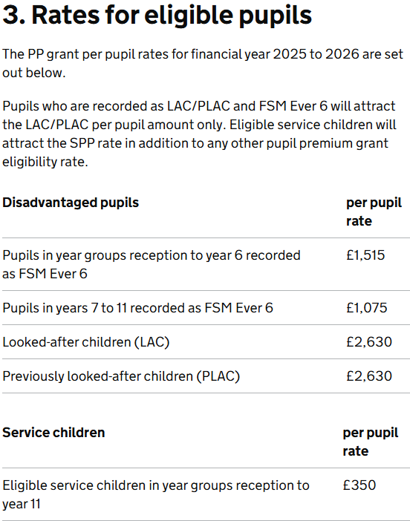
Service pupil premium is additional funding for schools with pupils who have parents serving in the armed forces. It has been combined into pupil premium payments to make it easier for schools to manage their spending. Pupils in state-funded schools in England attract the service pupil premium grant, at the rate of £350 per eligible pupil in financial year 2023-24.
Education & Skills Funding Agency
To be eligible for free school meals you must be in receipt of the appropriate benefits and have submitted an application for free school meals to the Local Authority Benefits Team (details of which are available from the school office).
If you qualify for the appropriate benefits, but have chosen not to apply for free school meals, please consider applying. You do not have to take up the free school meal to attract the funding. Free school meals cannot be backdated, so you should only apply if you currently qualify.

Part B: Review of the previous academic year

Outcomes for disadvantaged pupils
This details the impact that our pupil premium activity had on pupils in to 2025.
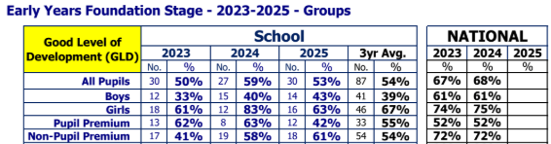
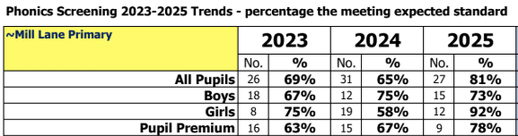
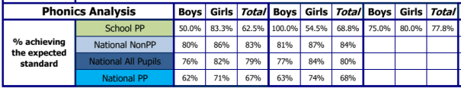

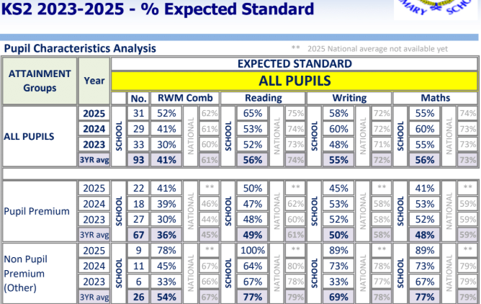
We have analysed the performance (see next page) of our school’s disadvantaged pupils during the previous academic year, drawing on national assessment data and our own internal summative and formative assessments.
The data demonstrated that:
In Reception, there was a dip this year following a 3-year upward trend and a reverse of the pupil premium children outperformed non-pupil premium children we have seen in previous years.
In Y1 phonics, there is a 3-year upward trend and pupil premium children outperformed others.
In KS2 combined Reading, Writing and Maths, there is a 3-year upward trend.
In KS2 Reading, there is an upward trend.
In KS2 Writing, following a 3-year upward trend, there has been a dip for pupil premium children this year.
In KS2 Maths, following a 3-year maintained trend, there has been a dip for pupil premium children this year.
To help us gauge the performance of our disadvantaged pupils we compared their results to those for disadvantaged and non-disadvantaged pupils at national and local level and to results achieved by our non-disadvantaged pupils (though we know that pupils included in the performance data will have experienced some disruption due to Covid-19 earlier in their schooling, which will have affected individual pupils and schools differently).
We have also drawn on school data and observations to assess wider issues impacting disadvantaged pupils' performance, including attendance, behaviour and wellbeing.
Based on all the information above, the performance of our disadvantaged pupils was disappointing this year but was cohort specific. We are at present on course to achieve the outcomes we set out to achieve by 2026/27, as stated in the Intended Outcomes section above.
Our evaluation of the approaches delivered last academic year indicates that, although outcomes were lower than previous years, interventions helped to close the gap.
We have reviewed our strategy plan and made changes to how we intend to use some of our budget this academic year. The Further Information section below provides more details about our planning, implementation, and evaluation processes.

Externally provided programmes
Programme | Provider
PiXL | PiXL
Reading Plus | Reading Solutions
Lexia | Lexia Learning
Times Tables Rock Starts | Maths Circle Limited

Service pupil premium funding:
Measure | Details
How did you spend your service pupil premium allocation last academic year? | N/A
What was the impact of that spending on service pupil premium eligible pupils? | N/A

Further information
Additional activity
Our pupil premium strategy will be supplemented by additional activity that is not being funded by pupil premium. That will include:
- Embedding more effective practice around feedback. EEF evidence on feedback demonstrates significant benefits, particularly for disadvantaged pupils.
- Utilising a DfE grant to train a senior mental health lead. The training we have selected will focus on the training needs identified through the online tool: to develop our understanding of our pupils’ needs, give pupils a voice in how we address wellbeing, and support more effective collaboration with parents.
- Offering a wide range of high-quality extracurricular activities to boost wellbeing, behaviour, attendance, and aspiration. Activities will focus on building life skills such as confidence, resilience, and socialising. Disadvantaged pupils will be encouraged and supported to participate.
Planning, implementation, and evaluation
In planning our new pupil premium strategy, we evaluated why activity undertaken in previous years had not had the degree of impact that we had expected.
We triangulated evidence from multiple sources of data including assessments, engagement in class book scrutiny, and conversations with parents, students and teachers, in order to identify the challenges faced by disadvantaged pupils. We also worked with the LA and schools local to us with high-performing disadvantaged pupils to learn from their approach.
We attended LA PP Closing the Gap meetings, which included looking at several reports, studies and research papers about effective use of pupil premium, the impact of disadvantage on education outcomes and how to address challenges to learning presented by socio-economic disadvantage.
We used the EEF’s implementation guidance to help us develop our strategy, particularly the ‘explore’ phase to help us diagnose specific pupil needs and work out which activities and approaches are likely to work in our school. We will continue to use it through the implementation of activities.
We have put a robust evaluation framework in place for the duration of our three-year approach and will adjust our plan over time to secure better outcomes for pupils.

