WELLINGTON STREET, STOCKTON ON TEES

TS18 1QX, TEL: 01642 860055

Head Teacher: Mrs S Skillcorn
9th February 2026
Dear Mum, Dad / Carer

Parent Consultations
You are invited to our Spring term parent consultations which are to take place next month. You will receive a letter inviting you on either the evening of 10th or 12th March. When home and school work together, it has a great effect on your child’s self-esteem and progress, so it is important that you attend to see your child’s work and to chat to their class teacher about how well they are doing in school.

Greet your Child with a Smile, not a Mobile
Just a reminder that telephones are NOT to be used on the school yard for any reason, e.g. taking a call, texting, checking social media, etc. Please keep them in your pockets until you leave site. If you need to take an important call, please step out of the gate to do so.

World Book Day
We will be celebrating World Book Day on Thursday 5th March. Children are invited to come to school dressed as their favourite story book character. There is no need to buy a costume, home-made ones are always the best! Pete the Pirate is just jeans, T-shirt and a scarf or tea towel on the head as a bandana!

Residentials
This year we are taking children from Y5 and Y6 to Disney Land, Paris and children from Y3 and Y4 to London. School is VERY heavily subsidising these trips, so please make sure that payments are kept up to date. As tickets are already purchased, if you change your mind about your child going and have already signed the consent form, the cost of the tickets and hotels will still need to be paid if their place is not taken by another child.

Reading Books
We have a number of reading books not being returned to school. We need all books back for other children to read. We do not have any spare money to replace them. Please could you return ALL books as soon as possible. If they are lost or damaged, we require a £5 donation to go towards the cost of a replacement.

Professional Development (PD) Days
Each year all schools must take 5 PD days for staff training. At Mill Lane, we have already taken two which were on Monday 1st September 2025 and Tuesday 2nd September 2025. Our next ones will be on Friday 20th February 2026, Monday 20th July 2026 and Tuesday 21st July 2026, so school will be closed for our children on those 3 days.

PTO

Fasting
A number of parents choose for their adolescent secondary school aged children to fast during Ramadan. For primary school aged children, the school nurse recommends that this is done during weekends and during school holidays when parents can monitor their children for light-headedness or fainting etc. If any parent decides that they want their adolescent Y6 child to fast at school, this must be put in writing, signed and addressed to Mrs Skillcorn. A meeting will then be arranged in school to discuss arrangements for the child to ensure they do not become weak and pass out, such as being taken home at lunchtime, sitting down at playtime and not taking part in any strenuous activities such as PE and after school clubs. A Fasting Information Form will be completed during this meeting to ensure the safeguarding of the pupil. The Fasting Policy can be found on our website www.milllane.org.uk. Primary aged children cannot make this decision, only parents can, so if a child comes into school and says they are fasting without his/her parents arranging a meeting first, staff will ring parents to arrange one immediately.

Internet Safety Day
We celebrate Internet Safety Day this week by continuing to reinforce strategies to prevent our children from being abused and groomed online. You are invited to a workshop Tuesday 3:30-4pm to learn more about protecting your children from the dangers posed. Please come along.

Nursery Places
Our nursery is now full in both sessions. Please don’t assume your child will automatically get a place in our nursery if you have not filled out a form for the waiting list. If you know of any families with younger children, please ask them to go to the office to fill in a form. We still have places in Minis for 2-year-olds. If you would like a place, please speak to Mrs Douglas or Mrs Hegarty.
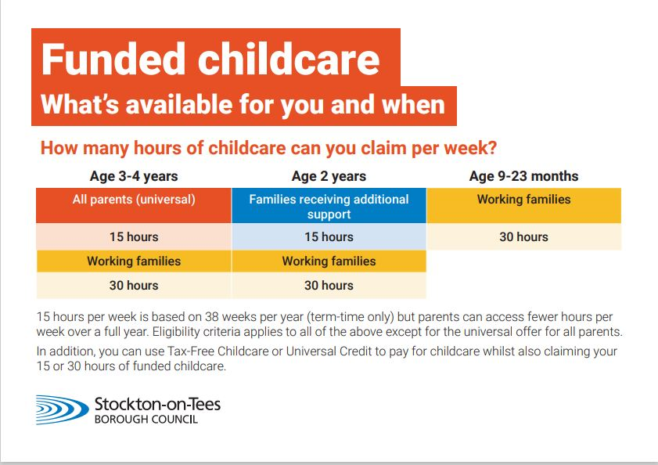
Visit www.beststartinlife.gov.uk for more information. To keep up to date on when you can start to claim the new funded childcare offer visit www.stockton.gov.uk/freechildcare or contact the Families Information service on 01642 527225.

Extending the Curriculum
This week is Children’s Mental Health Week and we celebrate Chinese New Year next week.
Angela Shackleton from Cleveland Fire Brigade came to school to hold a fire safety in the home assembly with Key Stage 2 children. Our poetry club children enjoyed a fantastic day competing in their first poetry slam competition. They were given a special commendation from one of the judges for their poise and confidence. PCSOs from Cleveland Police came into school to share safety messages on knife crime with our KS2 children as part of our PSHE enhanced curriculum.

Attendance
Mrs Petch has launched a new initiative to improve attendance. The Cupcake Challenge encourages classmates to come to school every day so that every child in the class with the best attendance can win a cupcake. Jo, the school cook, is personally baking them herself.

If a child is absent from school, for whatever reason, parents must inform the school in person, in writing or by telephone before 9am. The normal routine is to telephone the school. Calls are always logged, the class teacher informed and the register updated.

Please ensure your child attends school every day (unless a health professional advises otherwise) so they have the best chance of reaching their potential. If your child is ill and unable to attend school, please let us know immediately by ringing the school 01642 860055 and leaving a message.
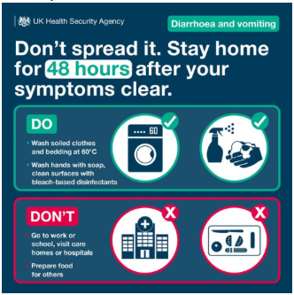

Year Group | Attendance
Nursery | 85%
Reception | 89%
Y1 | 93%
Y2 | 95%
Y3 | 95%
Y4 | 97%
Y5 | 95%
Y6 | 93%
Total | 95%

National average is 96%

Sporting Success
Years 1 and 2 had a 'jolly olde time' at the SSSP's Pirate Festival focusing on developing fundamental movement skills while incorporating imaginative role-play within 'Captain's Commands, Treasure Steal and Walking the Plank Obstacle Race' to improve agility, balance, coordination and social skills in team games. They even had to walk the plank! Our Reception children had a wonderful time at the Stockton Schools Sports Partnership Sports Festival where they worked hard developing their gross motor skills.

Community Shop and Café
Sprouts Community Shop and Café is open every Thursday 10am-1pm at The Family Hub, Yarm Road, Stockton TS18 3PJ. They offer low-cost quality food and free refreshments. Everyone is welcome. You can just pop in. No referral is needed. Telephone number is 07980 808920 and the email is info@sproutscommunityfoodcharity.org
We still run the Mill Lane Mini Market every Friday outside Y2 classroom on the yard where you can help yourself to a range of free food for the weekend. Mrs Petch also offers the £1 or £2 grocery bags. Please speak to her on the Nursery gate. PTO

The Greatest Gift you can give your Child
According to teacher and education speaker Mr P, the one thing that makes the biggest difference in the classroom? Reading. At home. With you.
Whether it’s ten minutes before bed, the same book on repeat, or a bleary-eyed story with dodgy accents – what really matters is showing your child that words matter. That they matter.
You’re not just reading a book. You’re building confidence. Vocabulary. Imagination. A lifelong love of learning.
“As a teacher, I can’t tell you which kids were bottle fed or breastfed when they were babies. I can’t tell you which kids have always been decked out in the latest designer clothes. I can’t tell you which ones have always had the newest toys. I can’t tell you which kids started nursery early. But I CAN tell you which children have been read to regularly at home. Because you see it. You see it in their vocabulary, their confidence with words, their imagination, their ability to sit with a story and think. And here’s the thing. It’s not about being perfect. It’s not about reading for an hour every night. Sometimes it’s the same story over and over again. Sometimes it’s you half asleep, doing the voices terribly. But that time matters. Because when you read to your child, you’re not just teaching them how to read. You’re teaching them that books matter, that words matter, that they matter. And honestly, that’s one of the greatest gifts you can give your child.”.

All of our children are expected to practise their reading at home for 15 minutes at least 3 times a week. We check their Reading Record weekly to ensure YOU have got them to do so. If they haven’t, for whatever reason, then they stay in at playtime and read to the Head Teacher so that they don’t fall behind. Please ensure they do this at home as it is so important to their education.

Staffing
We say goodbye to our caretaker, Mr Trattles, at half term and welcome Mr Colliwell who takes over in March. Mr Trattles has covered the caretaking role since September, and we thank him for all of his hard work in that time. We also said goodbye to mid-day supervisor, Mrs Taylor. We wish her well in her new role and welcome Ms Hammond to the team.

Healthier Together
Healthier Together is an online website and mobile application that can enable parents and carers to make informed decisions about accessing appropriate local healthcare services for their baby or child. If parents are unsure whether their child needs to be seen by a doctor, the easy-to-follow guidance on Healthier Together will ease worry and ensure people are signposted to the best service to provide help, such as a pharmacy or GP, or to self-care at home. It also ensures those who most need to be seen urgently are advised to seek the correct help. Healthier Together also has information for older children and teenagers to find out about issues relevant to them and how to access support. It is important that this is accessed by all our communities. This can be found at https://www.nenc-healthiertogether.nhs.uk/parentscarers/worried-your-child-unwell/child-unwell-ok-go-nurseryschool

Holiday Club and Benefits
We break up for one week for half term on Thursday 19th February and will see the children back at school 8:45am Monday 2nd March. We will be running holiday club in Mill Lane during the half term holidays, so please book your child on and ensure they come to this free club for children with parents in receipt of benefits and who are eligible for free school meals. If you receive any benefits, even if you are also working, please ask at the office, as your child might also be entitled to free school meals and the benefits that come with this like extra school funding, holiday club and vouchers.

Phone Numbers
Please make sure you keep all phone numbers up to date, especially if you change your phone or number, so that we can contact you in an emergency or return your call should you ring us.

Governors
Governors play a crucial role in our school. School governors are volunteers performing a strategic role that drives school improvement, sets the vision, and ensures financial accountability without managing daily operations. They act as "critical friends" to the headteacher, holding leadership accountable for educational performance, pupil safety, and policy compliance. If you feel you would like to join the team as a parent governor or simply find out more, please speak to any governor below. You are very welcome.
Our governors are:
Chair of Governors Barbara Robinson
Vice Chair of Governors Marian Dalgleish
Parent Governor Louise Marr
Parent Governor Vacancy
Staff Governor Lynsey Hegarty
Local Authority Governor Cllr Pauline Beall
Governor John Taylor
Governor Elaine Dodsworth
Co-opted Governor Rachel Conroy
Head Teacher Sue Skillcorn
Governor Support Janet Tasker

Dates for your Diary
Tuesday 10th February Safer Internet Day. Parent workshop 3:30-4pm. Please come along**
Thursday 19th February Break up for half term holiday (20th is a PD Day so closed)
Monday 2nd March Return to school
Monday 2nd March Careers Week
Thursday 5th March World Book Day – children dress as favourite book
character
Monday 9th March British Science Week
Tues 10th & Thurs 12th March Parent consultations
Friday 20th March Red Nose Day – wear something red to school
Thursday 26th March Easter disco
Thursday 2nd April Break up for Easter holiday (Friday 3rd is a bank holiday)
Monday 20th April Return to school
Thursday 23rd April School Photograph Day
Monday 4th May Bank Holiday so school is closed
Friday 22nd May Break up for half term holiday
Monday 1st June Return to school
Friday 17th July Break up for summer holidays (20th and 21st are PD Days)

Keeping you Informed
I endeavour to keep parents up to date and informed. More information can be found on our website, www.milllane.org.uk or on our Mill Lane Facebook Page (just click ‘like’ for updates).

Compliments, Comments and Complaints
Staff work exceptionally hard at Mill Lane to ensure children are happy and very well educated. If you have any compliments, comments or concerns, I am always happy to listen, act and explain.

Thank you for your continued support.
Yours sincerely
Mrs Skillcorn
Head Teacher

